**Theory:** Companies with strong fundamental balance sheet, high cash reserves, and low debt will be better equipped to weather the COVID-19 market storm relative to their competitors

**Goal:** Establish list of S&P 500 stocks with strong balance sheet fundamentals with a focus on ***Total Debt to Cash*** ratio. Use current PE ratio compared to YE 2019 to identify potential undervalues.

**Data Gathering**

* Fundamental Income Statement and Balance Sheet metrics were scraped from Market Watch using Python’s Beautiful Soup package. (Thanks to Vincent Tatan for getting me the initial shell. [Value Investing Dashboard with Python Beautiful Soup and Dash Python](https://link.medium.com/siL0vVKhp7))
* Stock pricing data was downloaded using the yahoo finance package yfinance: <https://pypi.org/project/yfinance/>

Note: I’ll be using the following vernacular throughout:

* **D2C**: Debt to Cash ratio calculated by dividing total debt by total cash
* **MRQ**: Most Recent Quarter Reported (Q1 2020)
* **TTM**: Trailing 12 months – rolling 4 quarters reported as of Q1 2020 (March 31, 2020).
  + For example TTM EPS would be [Q2 2019 + Q3 2019 + Q4 2019 + Q1 2020]

**Step 1: Pull Debt to Cash Ratios for All S&P 500 companies as of 2019YE. Assess who would be starting off 2020 with a strong balance sheet.**

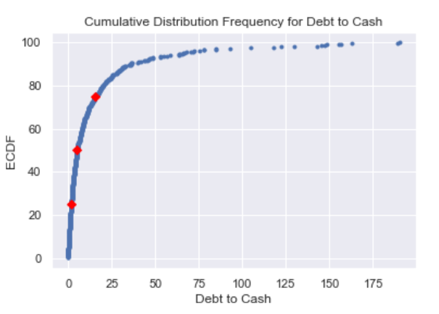

*Right off the bat I’m going to filter out the companies who live in this range. Top 25th percentile*

* Y axis represents D2C percentiles
* The red dots represent the 25th, 50th, and 75th percentiles.
* Each blue dot represents the intersection of a company’s D2C ratio and it’s respective percentile relative to the population

**Step 2: (a) Download stock prices for YE 2019 and calculate the 30 day moving average as of 06/17’s close. (b) Calculate additional key metrics not included in Market Watch’s data.**

* Used the 30-day moving average for the recent stock price to try and smooth out market volatility
* The following calculations were derived in this set which will be referenced throughout:
  + **YE PE**: Year End Price to Earnings ratio. Stock price as of 12/31/2019 divided by Year End 2019 EPS
  + **TTM PE**: Trailing Price to Earnings Ratio. 30 day moving average stock price as of 06/17 divided by TTM EPS (the past 4 quarters of EPS added together. Most recently reported Q1 2020)
  + **PE Variance**: TTM PE minus YE PE
  + **D2C Change**: [ MRQ D2C minus YE D2C ] / YE D2C. (The percent change in D2C)

**Step 3: Screening Criteria**

* As I stated in Step 1, the list has already been pared down to filter companies whose D2C ratios are in the top 25th percentile
* The following screening metrics were used to get to my final list:
  + YE 2019 EPS Growth was **positive**
  + TTM EPS is **positive**
  + PE Variance was **negative.** The logic being that the market is currently undervaluing companies with strong balance sheets who have dropped in PE ratio since YE 2019
  + Less than a 10% increase in D2C ratio. I don’t want companies who took on a substantial amount of debt in the first quarter as compared to their YE 2019 number.
* Results are downloaded in the attached with all key metrics for reference – paired down to only 20 stocks. Pick at your own risk.
* Note: I added an “Extra Credit” column in the file that awards one point for companies who decreased debt in the first quarter and one point for companies who managed a positive EPS growth (also in Q1)



**Appendix: Average D2C and PE Ratios by Sector for Q1 2020**

